Dominic Drury

05/27/2024

CS-405

4-1 Activity: Exceptions

Screenshot of the application console output

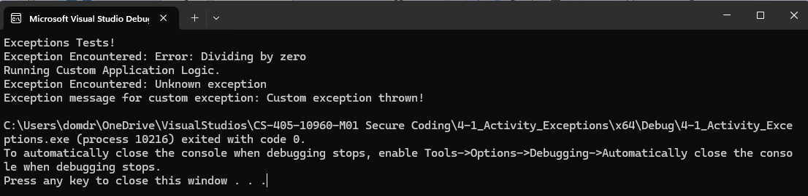

Brief Process Summary

A debugging that is both systematic and thorough involves going through the logic of your code and ensuring that the actual functionality matches the intended functionality of the program. This means that the code is free of the common bugs like typos, null pointer references, incorrect namespace usage, and for me specifically with this project, forgetting to include arguments to function calls. When I wrote my custom exception I put it to take a string of characters in order to print that error message, but I forgot and left it as

throw CustomException();

instead of

throw CustomException("Custom exception thrown!");